**STAT 40001/STAT 59800 Statistical Computing Fall 2020**

**Lab -21**

1. A real estate agent used information on 1115 houses. She wants to predict whether a house sold in the first 3 months it was on the market based on other variables. The variables available include:

*Sold Price :* 1 = Yes—the house sold within the first 3 months it was listed;

0 = No, it did not sell within 3 months.

*Price:*  The price of the house as sold in 2002.

*Living Area:* The size of the living area of the house in square feet

*Bedrooms :* The number of bedrooms

*Bathrooms :* The number of bathrooms (a half bath is a toilet and sink only)

*Age:* Age of the house in years

*Fireplaces:* Number of fireplaces in the house

Fit a multiple logistic regression model to predict whether a house will sell within the first 3 months it’s on the market based on Price ($), Living Area (sq ft), Bedrooms (#), Bathrooms (#), Fireplaces (#), and Age (years).

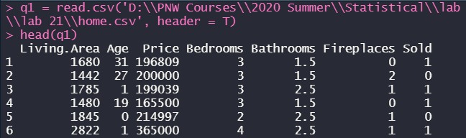



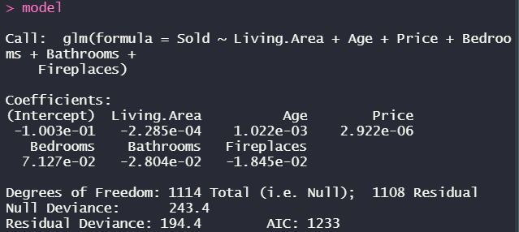

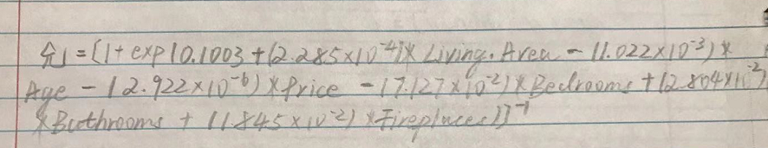

1. A local health clinic sent fliers to its clients to encourage everyone, but especially older persons at high risk of complications, to get a shot in time for protection against an expected flu epidemic. In a pilot follow-up study, 159 clients were randomly selected and asked whether actually received flu shot. A client who received flu shot is coded Y=1 and client who did not receiveflu shot was coded Y=0. In addition, the data was collected their age (X1), and the their health awareness. The health awareness (X2) is indexed with higher value indicating greater awareness. Also the gender of the client (X3 = 1 for male and X3 = 0 for female) was recorded. The data is provided in the Blackboard. Assuming that a multiple logistic regression best fit the data, answer the following questions:
2. Fit a multiple logistic regression model and check for significance of each variable (X1, X2 and X3)

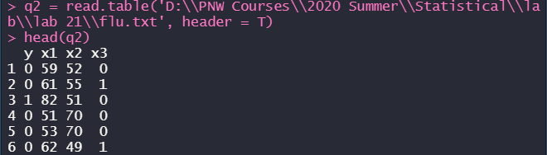

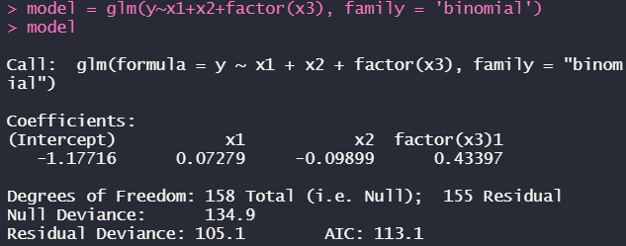

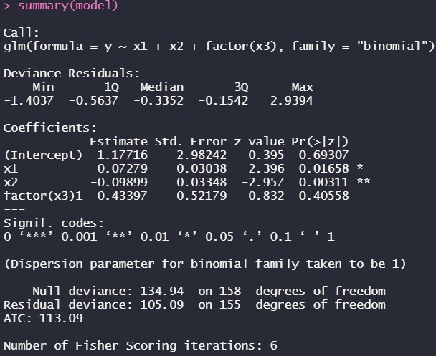

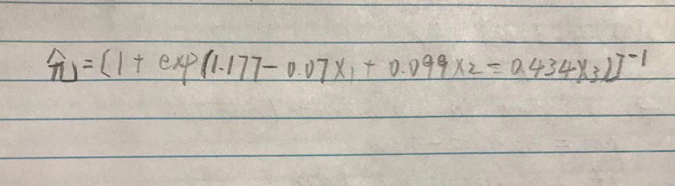

1. What is the estimate probability that a male client aged 55 with a health awareness index 60 will receive a flu shot?

